2023-2026 TIP Environmental Justice Benefits and Burdens Analysis
Presidential Executive Order 12898 on Environmental Justice (EJ) focuses federal attention on the environmental and human health effects of federal actions on minority and low-income populations with the goal of achieving environmental protection for all communities. Within the transportation field, environmental justice is guided by three core principles:
- To avoid, minimize, or mitigate disproportionately high and adverse human health and environmental effects, including social and economic effects, on minority and low-income populations.
- To ensure the full and fair participation by all potentially affected communities in the transportation decision-making process.
- To prevent the denial of, reduction in, or significant delay in the receipt of benefits by minority and low-income populations.
In 2019, the South Central Pennsylvania MPO EJ Process Development Study was released. The Unified Environmental Justice Process and Methodology Guide was the result of an inter-regional collaborative process by MPOs in PennDOT District 8, PennDOT Central Office, the Federal Highway Administration, and the Federal Transit Administration.

A key portion of the new methodology is the definition of Low-Income and Minority Populations.

- Low-Income – The FHWA and USDOT EJ Orders define a “low-income” individual as a person whose median household income is at or below the Department of Health and Human Services (HHS) poverty guidelines.
- Minority Populations – The FHWA and USDOT EJ Orders define a “minority” individual as a person who is:
  - (1) Black
  - (2) Hispanic or Latino
  - (3) Asian American
  - (4) American Indian and Alaskan Native
  - (5) Native Hawaiian and Other Pacific Islander

The core methods outlined in the guide are:
- Identify Environmental Justice Populations
- Assess Conditions and Identify Needs
- Evaluate Benefits and Burdens of Program
- Identify and Address Disproportionately High and Adverse Impacts

This report summarizes the activities, analyses, and outcomes that were completed as a part of the SEDA-COG MPO 2023 Transportation Program development process in compliance with Environmental Justice policies.

Identify Environmental Justice Populations

In response to the identified EJ policies, a distributive geographic analysis was conducted to identify the locations and concentrations of minority and low-income populations. The demographic profile describes the social composition of the SEDA-COG MPO region and illustrates how demographic patterns vary spatially.

The identification of these populations is essential to establishing effective strategies for engaging them in the transportation planning process. When meaningful opportunities for interaction are established, the transportation planning process can draw upon the perspectives of communities to identify existing transportation needs, localized deficiencies, and demand for transportation services. Mapping of these populations not only provides a baseline for assessing impacts of the transportation investment program, but also aids in the development of an effective public involvement program.

MPOs are expected to:
- Avoid the use of thresholds. The use of thresholds can cause some populations to be unaccounted for in the analysis because they are not of a certain size in comparison to the region.
- When mapping, use more disaggregated Census geographies (e.g., block groups). The more aggregated the geographic level of the analysis, the higher the probability that pockets of low-income and minority populations will be missed.
- Consider geographically dispersed or transient persons. USDOT guidance directs funding recipients to consider all people present in an area, not just the residents. Non-resident persons who travel through or to an area and belong to minority or low-income populations should be considered.
- Verify data and be aware of limitations. Much of the data used in the process are estimates and may have significant margins of error.
- Engage representatives and leaders of minority or low-income populations. MPOs should conduct outreach to leaders of minority or low-income populations to verify data and gain a deeper understanding of the culture and diversity of the area.

The American Community Survey (ACS) provides information on the characteristics of the population – and is not meant to count the population. ACS data are sample data and different samples would yield different estimates of the actual population value. Approximately 1 in 38 U.S. households per year receives an invitation to participate in the ACS. The margin of error is a measure of the possible variation of the estimate around the population value. ACS estimates carry larger margins of error than decennial Census sample estimates. This is especially true for small areas and population groups. Due to the small population located within certain Census tracts in the SEDA-COG MPO region, margin of error must be considered when considering the population represented by the data.

Table 1 provides a summary of the U.S. Census ACS 2015-2019 5-Year Estimates data at the county and MPO levels. The regional average of minority populations is 7.34%. This is an increase from the 2011-2015 ACS dataset of 7.02%. The regional average for population for whom poverty status is determined has remained consistent from previous years at ~13%.

Table 1: Profile of Traditionally Underserved Populations in the SEDA-COG MPO Region | SEDA-COG MPO Region
 | Clinton County | Columbia County | Juniata County | Mifflin County | Montour County | North- umberland County | Snyder County | Union County | Total Population | Regional Threshold (Average Concentration)
Total Population | 38,915 | 65,715 | 24,624 | 46,276 | 18,259 | 91,761 | 40,483 | 45,111 | 371,144 | 7.34%
Minority Population1 | 1,880 | 4,462 | 742 | 1,429 | 1,582 | 6,897 | 1,990 | 7,147 | 26,129
Senior Population2 | 7,121 | 12,443 | 4,896 | 9,787 | 3,768 | 19,142 | 7,419 | 7,996 | 72,572 | 19.6%
Total Population for whom Poverty Status is Determined | 37,185 | 61,000 | 24,326 | 45,537 | 17,546 | 87,589 | 38,125 | 36,023 | 347,331 | 13.05%
Low-Income Population3 | 5,777 | 9,150 | 2,637 | 6,127 | 1,836 | 11,552 | 3,983 | 4,258 | 45,320
Total Population Age 5 or Older | 36,838 | 62,775 | 23,208 | 43,417 | 17,207 | 87,029 | 38,314 | 43,026 | 351,814 | 1.96%
Limited English Proficiency Population4 | 613 | 559 | 941 | 1,159 | 301 | 1,256 | 902 | 1,174 | 6,905
Total Civilian Non-Institutionalized Population | 38,358 | 64,957 | 24,386 | 45,674 | 17,584 | 87,881 | 40,150 | 39,694 | 358,684 | 14.8%
Disabled Population5 | 6,368 | 9,037 | 3,327 | 7,288 | 2,423 | 14,574 | 4,842 | 5,216 | 53,075
Total Households | 14,690 | 26,372 | 9,372 | 19,043 | 7,404 | 39,075 | 14,794 | 14,533 | 145,283 | 9.3%
Zero Vehicle Households6 | 1,450 | 1,721 | 729 | 2,118 | 1,016 | 4,141 | 1,043 | 1,290 | 13,508
Female Head of Household with own Children7 | 474 | 990 | 184 | 793 | 348 | 1,513 | 497 | 494 | 5,293 | 3.64%

Source: U.S. Census Bureau, American Community Survey (ACS), 2015-2019 5-Year Estimates
Notes:
1 Minority Population: Table DP05, ACS Demographic and Housing Estimates, - RACE- Calculated as "Total Population" minus "One race - White".
2 Senior Population: Table DP05, ACS Demographic and Housing Estimates, SEX AND AGE - Value given as "Total Population: 65 years and over".
3 Low-Income Population: Table S1701, Poverty Status in the Past 12 Months - Value given as "Population for whom poverty status is determined: Below poverty level".
4 Limited English Proficiency Population: Table S1601, Language Spoken At Home - Value given as "Population 5 years and over: Language other than English: Speak English less than 'very well'".
5 Disabled Population: Table S1810, Disability Characteristics - Value given as "Total civilian non-Institutionalized population: With a disability".
6 Zero Vehicle Households: Table B08201, Household Size by Vehicles Available - Value given as "Total Households: No vehicle available".
7 Female Head of Household with Children: Table DP02, Selected Social Characteristics in the United States, Households by Type - Value given as "Family households: Female householder, no husband present family: With own children under 18 years".

For the statewide 2023 Transportation Improvement Program (TIP) environmental justice analysis, basic data and maps were developed by the Williamsport Area Transportation Study (WATS) MPO. All the data were refreshed, and the ACS-specific data were updated to the 2015-2019 estimates. The following statement explains the methodology used in the identification of minority and low-income populations from the Statewide Environmental Justice Analysis Methodology 2023-2026 Pennsylvania Transportation Improvement Program:

“The process followed for the 2021-2024 program update classified low income and
minority population percentages based on natural breaks of the percentages of those
populations present within the block groups of each county in Pennsylvania. The result of
this was to create a custom classification of symbol intervals for each county. The
presence of 67 different interval scales would lead to conducting 67 separate analyses
downstream in the workflow.

Instead, WATS staff found that when Census block groups were classified into intervals based on the ratio of census block group minority/low income percentage to county or region overall
minority/low income percentage (i.e. a ratio of “1” indicates a census block group has the
same minority or low income percentage as the county average) that they were able to produce
a uniform scale usable across all counties or regions in the state. One side effect of this
approach is that it resulted in some counties not having all intervals. However, it gives us a
uniform and easily communicated and understood way of classifying the relative
concentrations of low income and minority populations across the state of Pennsylvania.

As an example, based on the procedure described above, WATS staff defined interval “1” as being all Census block groups with a minority population percentage less than half the countywide or regional minority population percentage. The result is that any counties or regions with no Census block groups that fit that criterion do not have that interval. By standardizing the intervals across the state, we are able to make apples-to-apples comparisons between counties and regions and also the ability to scale the analysis up to larger geographic
scales (or down to smaller scales) which gives us a stronger analytical product.”

Figures 1 and 2 show the ratios of low income or minority population percentage in a Census block group to the MPO region low income or minority population percentage. As evidenced by the low-income map specifically, low-income populations are more densely represented in the northcentral portion of the region, as well as central Juniata County. The minority map similarly shows a high representation in the northcentral portion of the region but brings in some additional areas of Columbia, Montour, and southern Northumberland counties. It is important to note that two of the Census block groups in the northeastern portion of Union County are home to federal prisons.

Figure 1: Concentrations of Low Income Population
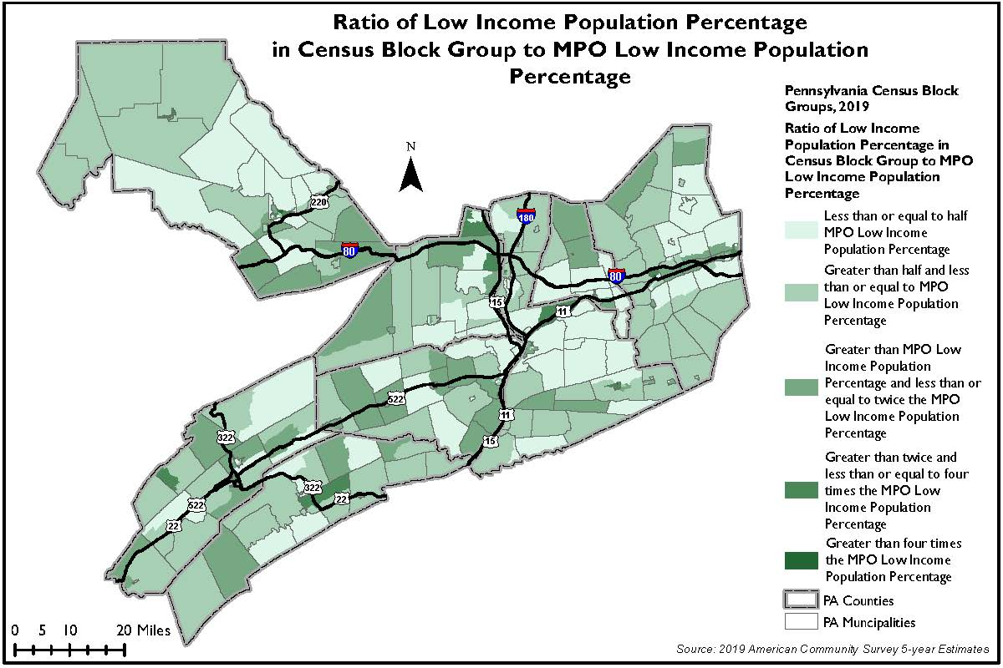
Figure 2: Concentrations of Minority Population
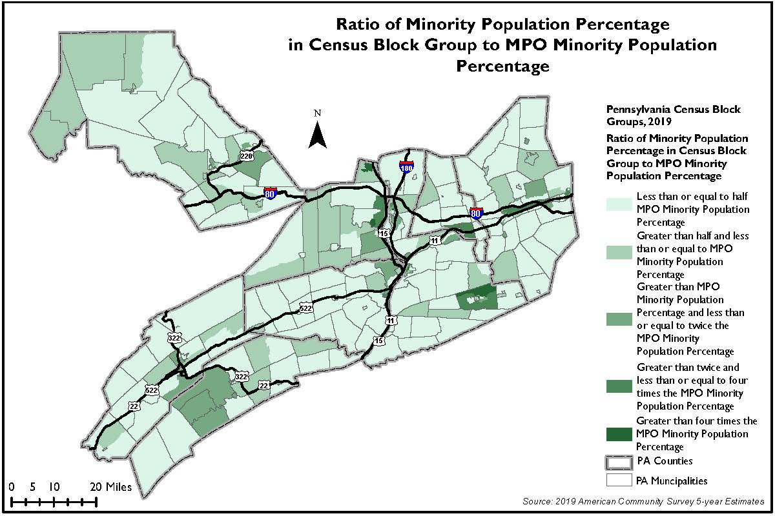

Figures 3 and 4 show dot density mapping of low income and minority populations by census block group.

Figure 3: Dot Density Concentrations of Low Income Population
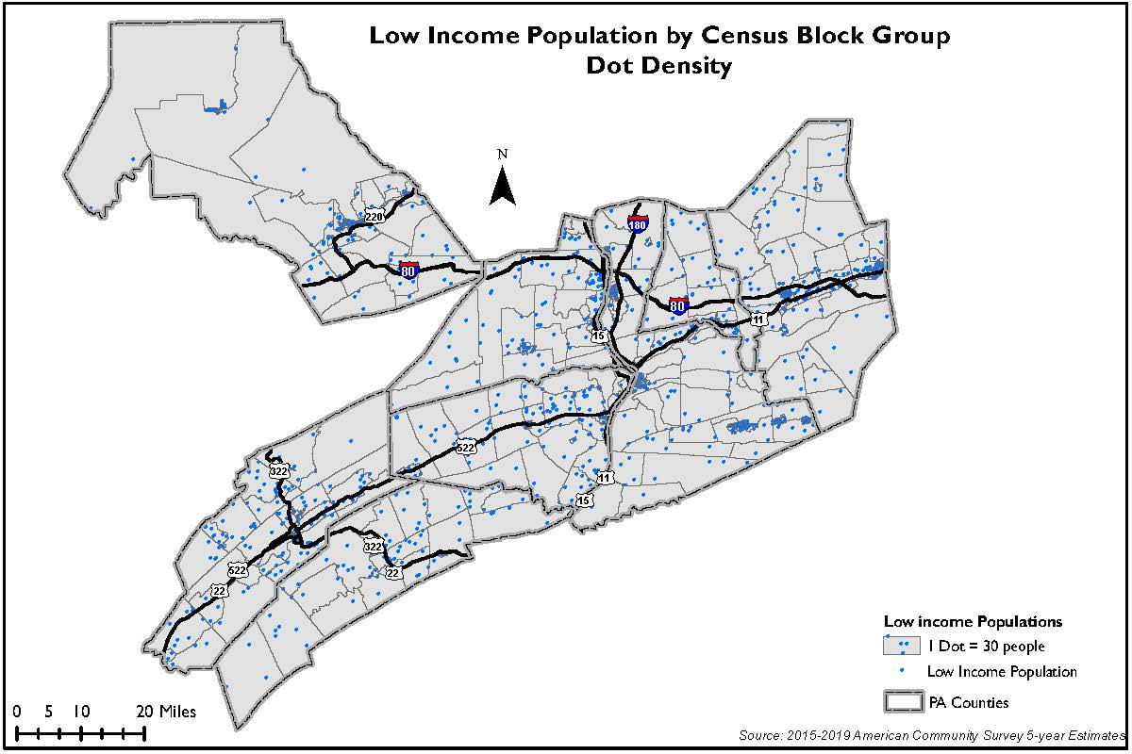

Figure 4: Dot Density Concentrations of Minority Population
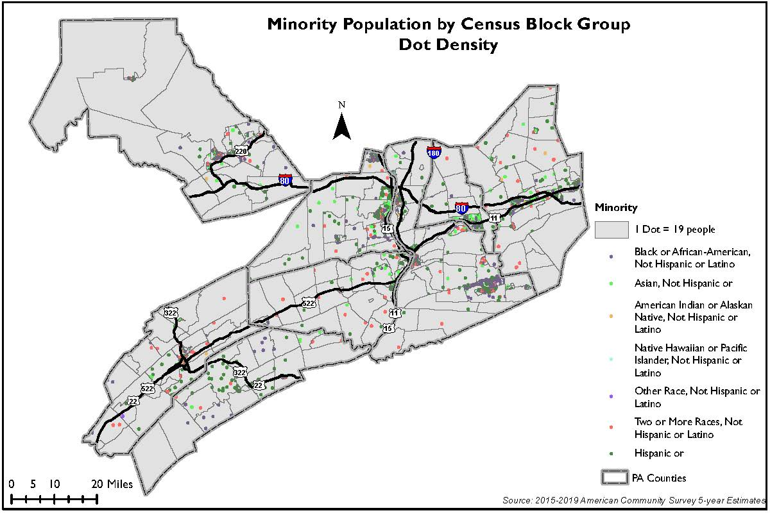

Tables 2 and 3 show the breakdown of low income and minority population totals across the block groups within these intervals throughout the SEDA-COG MPO region. The intervals referenced (1 through 5) are the same intervals shown on Figures 1 and 2 by the green gradient of color [lighter green equals interval 1; darkest green equals interval 5].

Table 2: Low Income Population by Interval
Low Income Population Interval | Low Income Population | Total Population | Percent Low Income
1 | 4,042 | 102,058 | 3.96%
2 | 11,389 | 117,211 | 9.72%
3 | 15,487 | 89,521 | 17.30%
4 | 12,600 | 35,478 | 35.51%
5 | 1,802 | 3,063 | 58.83%
Total | 45,320 | 347,331 | 13.05%

Table 3: Minority Population by Interval
Minority Population Interval | Minority Population | Total Population | Percent Minority
1 | 3,153 | 192,795 | 1.64%
2 | 4,125 | 77,201 | 5.34%
3 | 5,039 | 48,871 | 10.31%
4 | 8,412 | 40,293 | 20.88%
5 | 6,515 | 11,984 | 54.36%
Total | 27,244 | 371,144 | 7.34%

Assess Conditions and Identify Needs

Safety Conditions: Figures 5 and 6 highlight the bicycle and pedestrian fatalities in the region. The fatalities do not appear to be clustered in any specific area.

Figure 5: Concentrations of Low Income Population with Bicycle and Pedestrian Fatalities
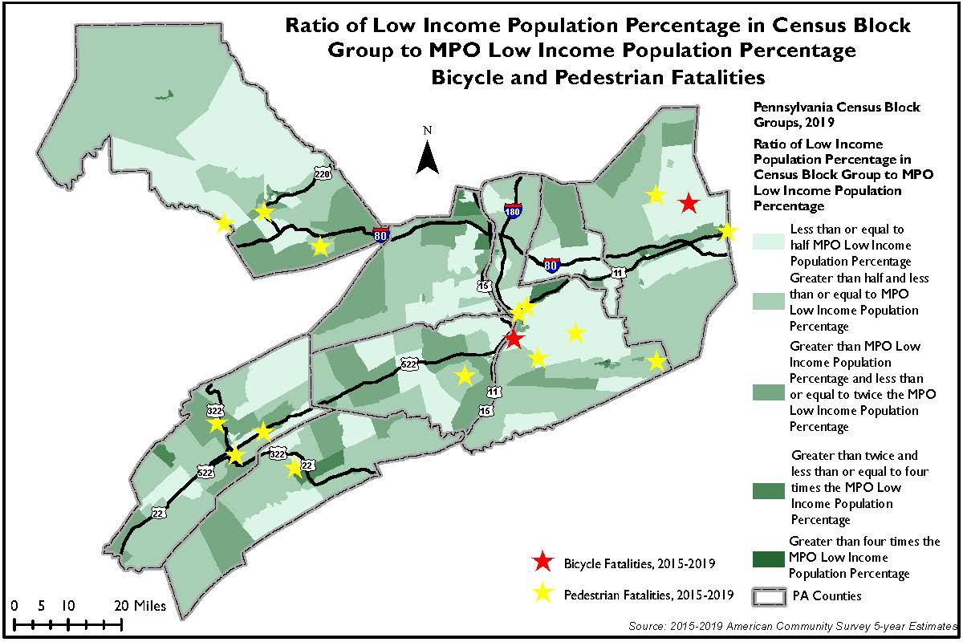
Figure 6: Concentrations of Minority Population with Bicycle and Pedestrian Fatalities
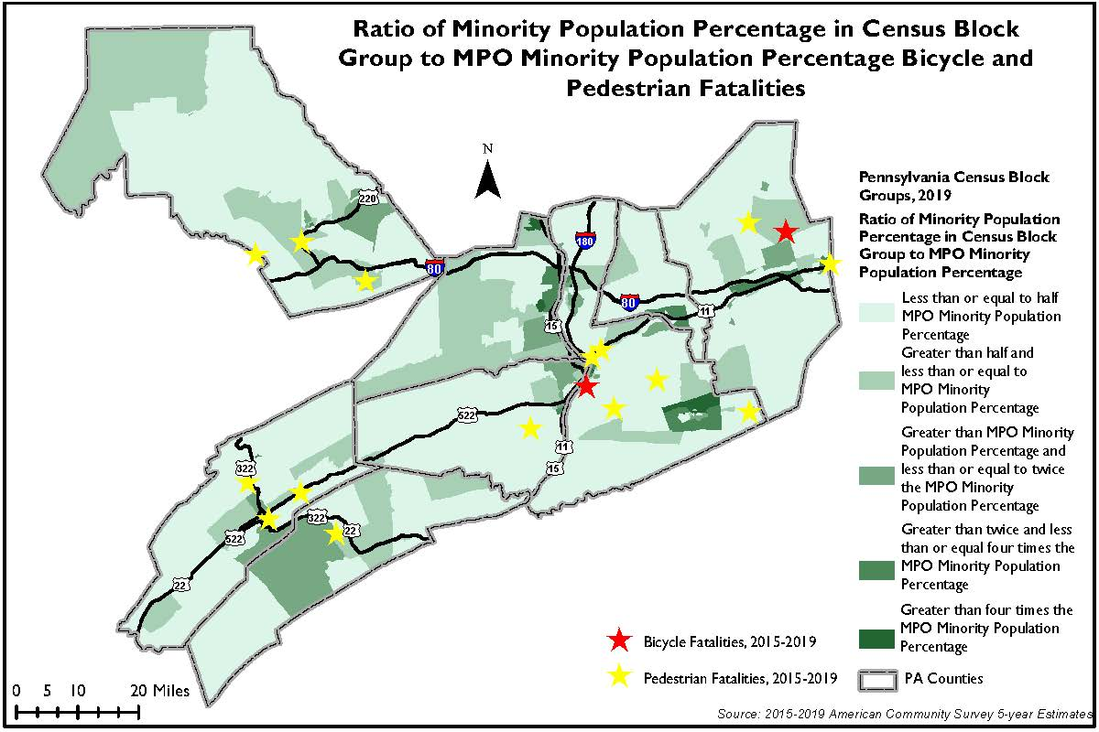

Tables 4 and 5 show bicycle and pedestrian crash data by interval in the SEDA-COG MPO region. The same color gradient applies to these tables as was discussed above in the Identification of EJ Populations section. These charts do include a column for horse and buggy crashes as well. This is particularly important to the MPO region, as there is a large Amish and Plain Sect population.

Table 4: Low Income Bicycle and Pedestrian Crash Data
Low Income Population Interval | Low Income Population | Total Population | Percent Low Income | People on Bicycles Involved in Crashes (2015 - 2019) | Pedestrians Involved in Crashes (2015 - 2019) | Total Persons Using Nonmotorized Modes Involved in Crashes (2015 - 2019) | Horse and Buggy Crashes (2015 - 2019)
1 | 4,042 | 102,058 | 3.96% | 23 | 85 | 147 | 11
2 | 11,389 | 117,211 | 9.72% | 34 | 75 | 177 | 22
3 | 15,487 | 89,521 | 17.30% | 30 | 96 | 175 | 15
4 | 12,600 | 35,478 | 35.51% | 18 | 79 | 110 | 2
5 | 1,802 | 3,063 | 58.83% | 0 | 19 | 21 | 0
Total | 45,320 | 347,331 | 13.05% | 105 | 354 | 630 | 50

Table 5: Minority Bicycle and Pedestrian Crash Data
Minority Population Interval | Minority Population | Total Population | Percent Minority | People on Bicycles Involved in Crashes (2015 - 2019) | Pedestrians Involved in Crashes (2015 - 2019) | Total Persons Using Nonmotorized Modes Involved in Crashes (2015 - 2019) | Horse and Buggy Crashes (2015 - 2019)
1 | 3,153 | 192,795 | 1.64% | 44 | 145 | 293 | 36
2 | 4,125 | 77,201 | 5.34% | 34 | 85 | 163 | 13
3 | 5,039 | 48,871 | 10.31% | 16 | 57 | 89 | 3
4 | 8,412 | 40,293 | 20.88% | 5 | 62 | 74 | 0
5 | 6,515 | 11,984 | 54.36% | 1 | 8 | 11 | 0
Total | 27,244 | 371,144 | 7.34% | 100 | 357 | 630 | 52

Tables 6 and 7 show general crash data by interval in the SEDA-COG MPO region. Most of the crashes fall in the first interval of minority and low-income populations.

Table 6: Low Income Crash Data
Low Income Population Interval | Low Income Population | Total Population | Percent Low Income | Total Reportable Crashes (2015 - 2019) | Persons Involved in Reportable Crashes (2015 - 2019) | Crash Fatalities (2015 - 2019) | Crash Suspected Serious Injuries (2015 - 2019)
1 | 4,042 | 102,058 | 3.96% | 6,408 | 13,580 | 85 | 286
2 | 11,389 | 117,211 | 9.72% | 6,720 | 13,451 | 90 | 344
3 | 15,487 | 89,521 | 17.30% | 5,523 | 12,091 | 79 | 241
4 | 12,600 | 35,478 | 35.51% | 1,961 | 4,681 | 11 | 69
5 | 1,802 | 3,063 | 58.83% | 210 | 486 | 1 | 6
Total | 45,320 | 347,331 | 13.05% | 20,822 | 44,289 | 266 | 946

Table 7: Minority Crash Data
Minority Population Interval | Minority Population | Total Population | Percent Minority | Total Reportable Crashes (2015 - 2019) | Persons Involved in Reportable Crashes (2015 - 2019) | Crash Fatalities (2015 - 2019) | Crash Suspected Serious Injuries (2015 - 2019)
1 | 3,153 | 192,795 | 1.64% | 11,194 | 23,240 | 161 | 577
2 | 4,125 | 77,201 | 5.34% | 4,914 | 10,690 | 75 | 188
3 | 5,039 | 48,871 | 10.31% | 2,314 | 5,078 | 18 | 87
4 | 8,412 | 40,293 | 20.88% | 1,889 | 4,198 | 11 | 61
5 | 6,515 | 11,984 | 54.36% | 295 | 686 | 3 | 20
Total | 27,244 | 371,144 | 7.34% | 20,606 | 43,892 | 268 | 933

Bridge Conditions: Figures 7 and 8 show the poor bridge condition by deck area for the region. Most of the poor condition bridges are under 3,000 square feet.

Figure 7: Concentrations of Low Income Populations with Poor Bridges
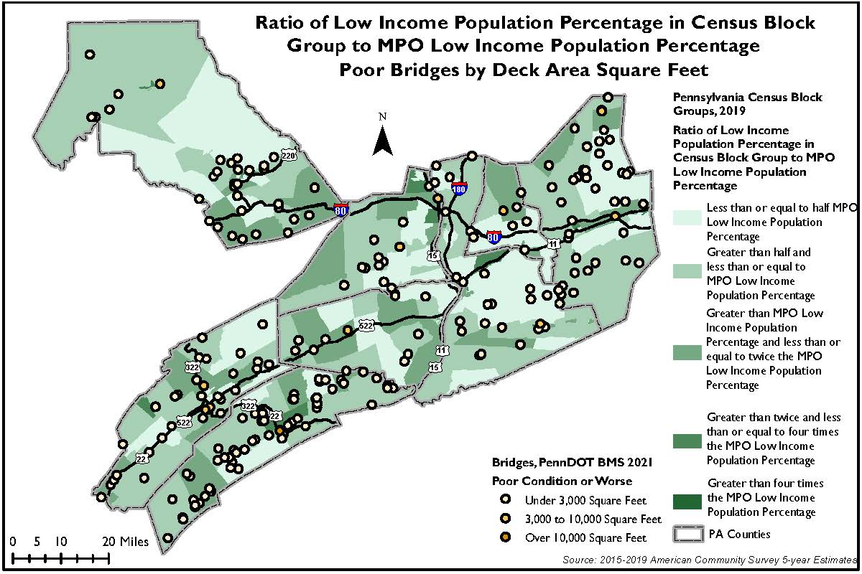
Figure 8: Concentrations of Minority Populations with Poor Bridges
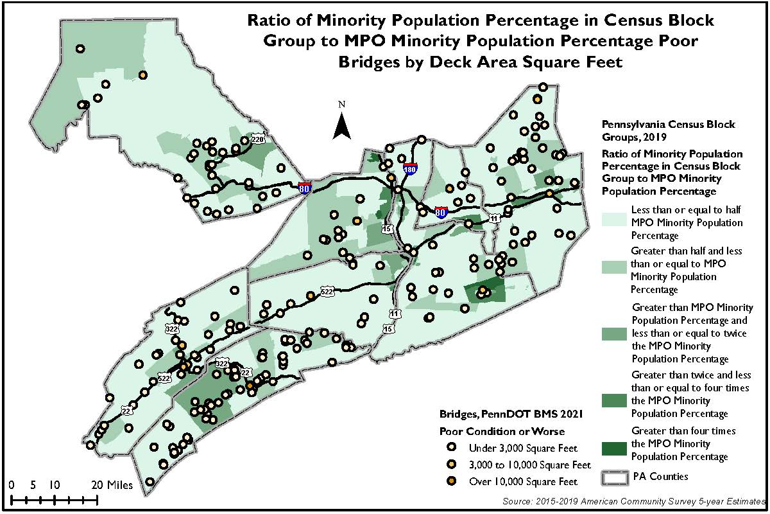

Tables 8 and 9 highlight the bridge conditions by interval in the SEDA-COG MPO region.

Table 8: Low Income Bridge Condition
Low Income Population Interval | Low Income Population | Total Population | Percent Low Income | Bridges in Poor Condition or Worse | Bridges in Fair Condition or Better | Total Bridges
1 | 4,042 | 102,058 | 3.96% | 65 | 1,199 | 1,264
2 | 11,389 | 117,211 | 9.72% | 132 | 1,550 | 1,682
3 | 15,487 | 89,521 | 17.30% | 60 | 903 | 963
4 | 12,600 | 35,478 | 35.51% | 11 | 165 | 176
5 | 1,802 | 3,063 | 58.83% | 0 | 4 | 4
Total | 45,320 | 347,331 | 13.05% | 268 | 3,821 | 4,089

Table 9: Minority Bridge Condition
Minority Population Interval | Minority Population | Total Population | Percent Minority | Bridges in Poor Condition or Worse | Bridges in Fair Condition or Better | Total Bridges
1 | 3,153 | 192,795 | 1.64% | 151 | 2,410 | 2,561
2 | 4,125 | 77,201 | 5.34% | 75 | 819 | 894
3 | 5,039 | 48,871 | 10.31% | 24 | 309 | 333
4 | 8,412 | 40,293 | 20.88% | 5 | 149 | 154
5 | 6,515 | 11,984 | 54.36% | 0 | 20 | 20
Total | 27,244 | 371,144 | 7.34% | 255 | 3,707 | 3,962

Pavement Conditions: Figures 9 and 10 show the fair and poor International Roughness Index (IRI) for roads in the MPO region. The Route 11 & 15 corridors (from Shamokin Dam-Northumberland) are highly traveled and see high numbers of truck traffic. Some of this situation may be alleviated with the completion of the Central Susquehanna Valley Transportation (CSVT) Project.

Figure 9: Concentration of Low Income Populations with IRI
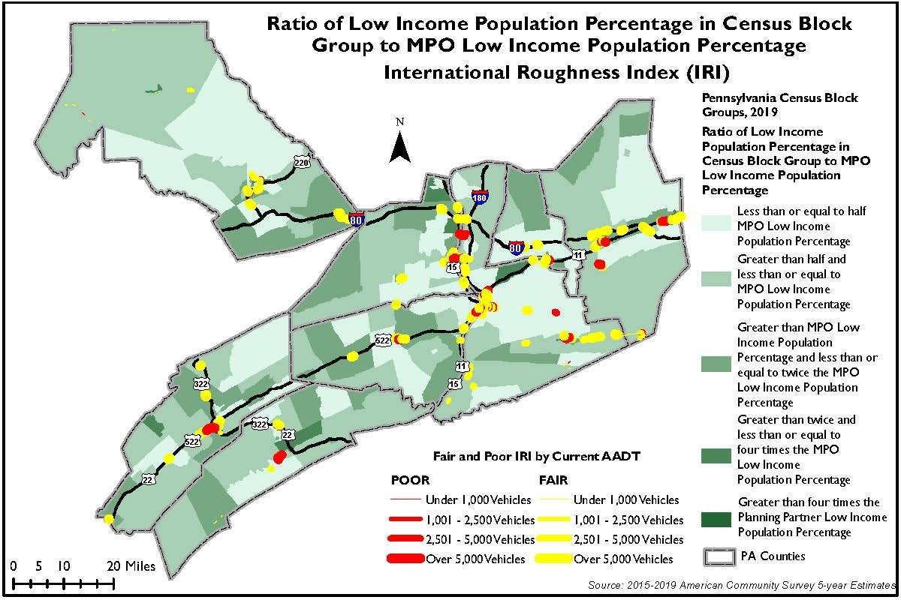
Figure 10: Concentration of Minority Populations with IRI
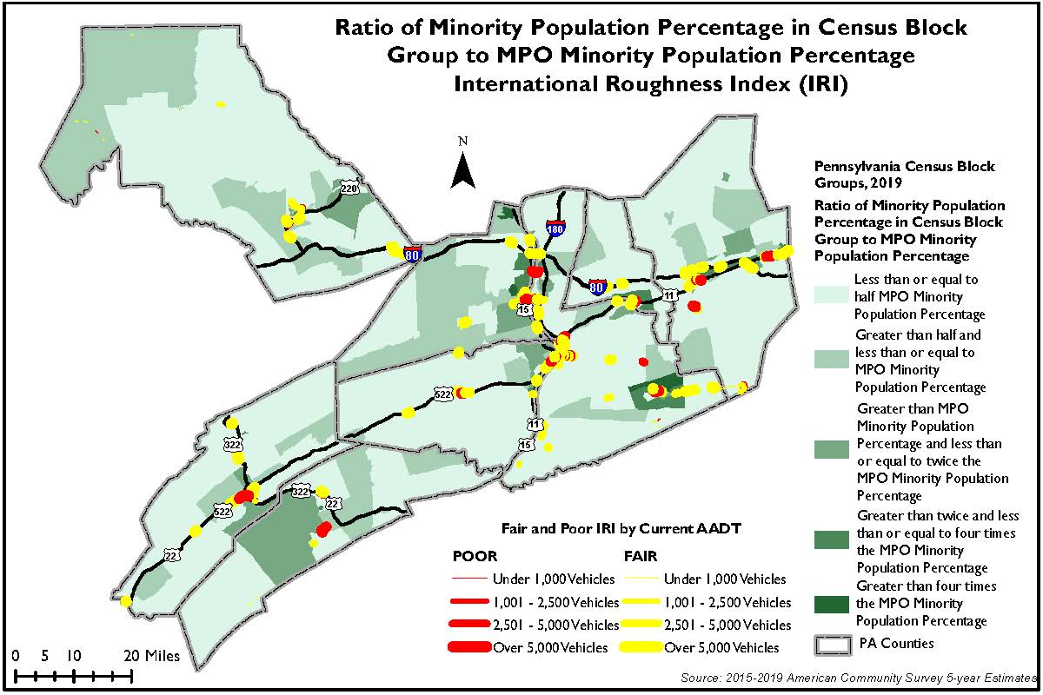

Tables 10 and 11 show the IRI data for minority and low-income populations.

Table 10: Low Income IRI
Low Income Population Interval | Low Income Population | Total Population | Percent Low Income | Federal Aid Segment Miles with EXCELLENT IRI | Federal Aid Segment Miles with GOOD IRI | Federal Aid Segment Miles with FAIR IRI | Federal Aid Segment Miles with POOR IRI | Federal Aid Segment Miles with OTHER IRI | Total Federal Aid Segment Miles (IRI)
1 | 4,042 | 102,058 | 3.96% | 224 | 85 | 18 | 4 | 1 | 332
2 | 11,389 | 117,211 | 9.72% | 331 | 131 | 30 | 6 | 2 | 499
3 | 15,487 | 89,521 | 17.30% | 191 | 85 | 27 | 7 | 1 | 311
4 | 12,600 | 35,478 | 35.51% | 39 | 22 | 10 | 5 | 0 | 76
5 | 1,802 | 3,063 | 58.83% | 1 | 2 | 1 | 1 | 0 | 5
Total | 45,320 | 347,331 | 13.05% | 787 | 324 | 85 | 23 | 3 | 1,223

Table 11: Minority IRI
Minority Population Interval | Minority Population | Total Population | Percent Minority | Federal Aid Segment Miles with EXCELLENT IRI | Federal Aid Segment Miles with GOOD IRI | Federal Aid Segment Miles with FAIR IRI | Federal Aid Segment Miles with POOR IRI | Federal Aid Segment Miles with OTHER IRI | Total Federal Aid Segment Miles (IRI)
1 | 3,153 | 192,795 | 1.64% | 489.60 | 175.06 | 47.46 | 6.70 | 1.54 | 720.35
2 | 4,125 | 77,201 | 5.34% | 170.49 | 67.39 | 18.73 | 6.87 | 1.82 | 265.31
3 | 5,039 | 48,871 | 10.31% | 48.13 | 28.99 | 11.66 | 4.68 | 0.00 | 93.46
4 | 8,412 | 40,293 | 20.88% | 42.09 | 24.79 | 8.87 | 1.78 | 0.00 | 77.52
5 | 6,515 | 11,984 | 54.36% | 9.57 | 6.78 | 1.88 | 1.23 | 0.04 | 19.51
Total | 27,244 | 371,144 | 7.34% | 759.89 | 303.00 | 88.60 | 21.26 | 3.41 | 1,176.14

Transit Conditions: Figures 11 and 12 show the fixed route transit facilities in the SEDA-COG MPO region. The SEDA-COG MPO region has only one fixed route transit system. It is the Lower Anthracite Transportation System (LATS). LATS has two seasonal routes to the Susquehanna Mall in the winter and Knoebels Amusement Park in the summer. LATS also has a fixed route throughout the southeast corner of Northumberland County.

Figure 11: Concentrations of Low Income Populations with Transit Providers
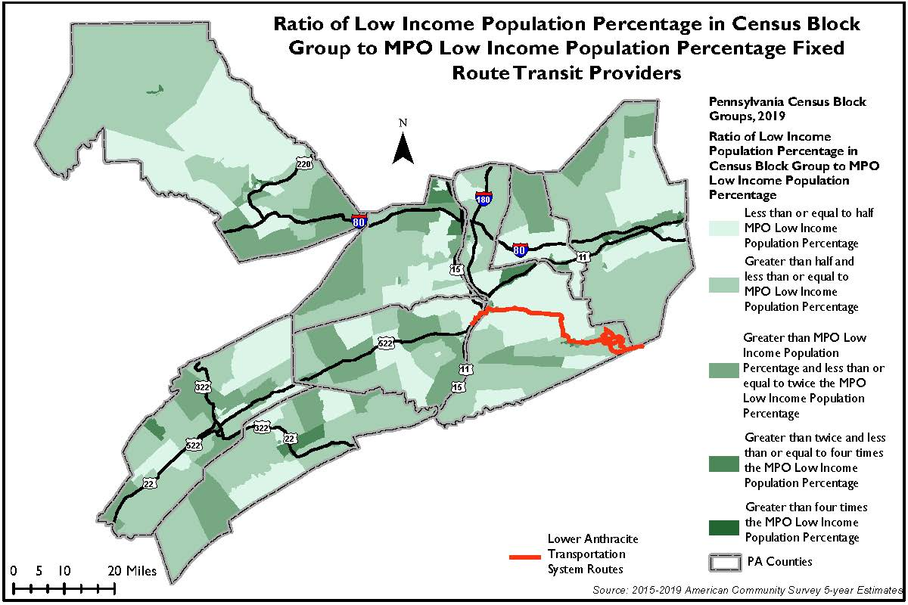
Figure 12: Concentrations of Minority Populations with Transit Providers
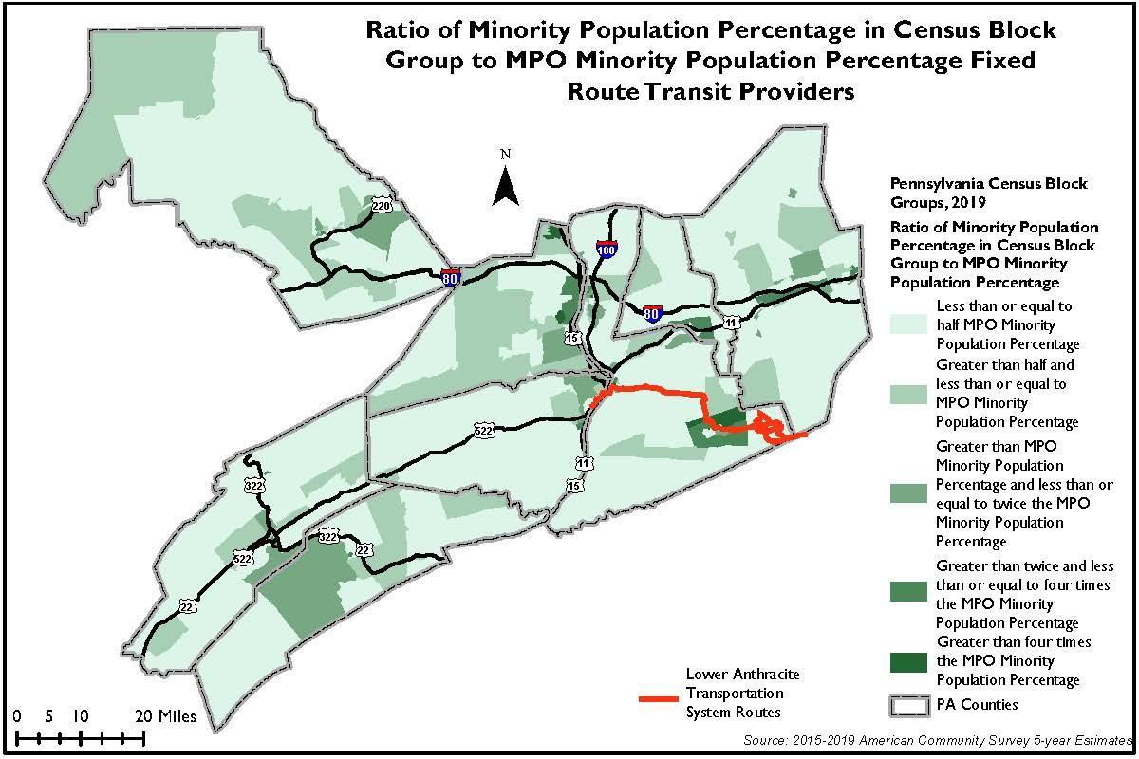
Evaluation of Benefits and Burdens of Program

The Benefits and Burdens Analysis provides feedback on the equity of the Transportation Improvement Program (TIP), examines the impact that it has on minority and low-income populations, and identifies any disproportionate impacts.

Benefits are the positive impacts from investment such as enhancements in transportation services/options, improved public safety, congestion relief, increased economic vitality, reduced travel times, etc. Burdens, on the other hand, are the adverse effects of investment such as pollution (noise and air), disruption of community cohesion, displacement of persons or businesses, destruction or decrease of economic vitality, adverse employment effects, decline in tax base or property values, diminished esthetics, disruption of businesses, parking/access to transit, congestion, or the denial, delay or reduction of receipt of benefits.

Per federal guidance, the evaluation of benefits and burdens for a program is to include project categorization, mapping, and a qualitative narrative.

Figure 13 and Figure 14 show the distribution of TIP projects throughout the region. The TIP projects are well distributed throughout the MPO region. The asset management projects that are located in areas with greatest minority population concentration may contribute to some short-term impacts during construction but will generally benefit those residents by improving traveling conditions and safety for all users. Bicycle, pedestrian, and transit projects would likely result in the least adverse impact and add the most benefit for minority and low-income populations.

Included on the TIP are five transit projects that do not lend themselves to being mapped. Those projects are as follows:

MPMS 115130 – Upgrade server/networking (Call A Ride Service, Inc.), $8,000
MPMS 115132 – Replace 5 computers (Call A Ride Service, Inc.), $7,500
MPMS 115139 – Purchase 20 Tablets (Call A Ride Service, Inc.), $6,000
MPMS 115140 – Replace small transit bus (Call A Ride Service, Inc.), $1,125,000
MPMS 115127 – Purchase Vehicles (Geisinger Health System Foundation), $2,050,000

Figure 13: Concentrations of Low Income Populations with TIP Projects
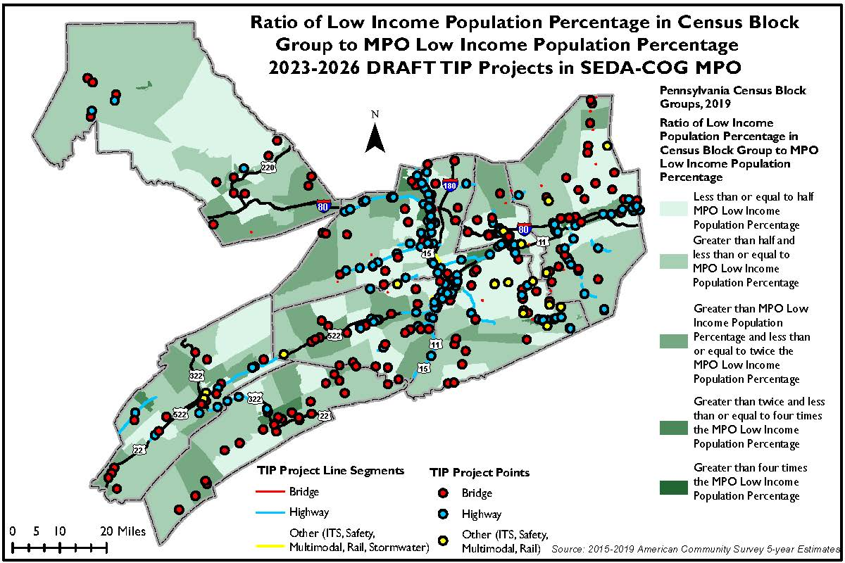

Figure 14: Concentrations of Minority Populations with TIP Projects
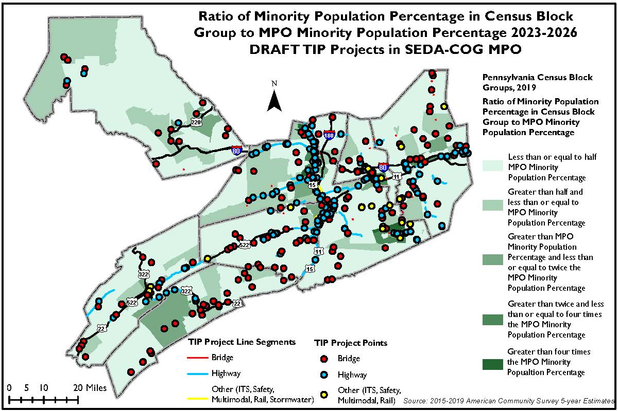

Table 12 is a categorization of all 2023 Draft TIP Projects. Each project was evaluated for proximity to low income or minority populations, as well as categorized as:

- Projects of Concern – High Potential for Adverse Impacts:
  - New Right-of-Ways
  - Roadway Expansion
- Lower Potential for Adverse Impacts/Potentially Beneficial:
  - Roadway and Bridge Maintenance
- Low Potential for Adverse Impacts/Inherently Beneficial:
  - Transit o Bike/Ped o Safety
  - Studies

Table 12 also uses a gradient color scheme for low-income and minority indications. The color scheme corresponds to the mapping included on the prior pages for the project distribution.

Table 12:
Project | County | Project Title | Minority | Low Income | High/Medium/Low Impact
3763 | Clinton | T-537 over Fishing Creek |  |  | Medium
3840 | Clinton | Rauchtown Bridge |  |  | Medium
3850 | Clinton | SR 1001 Improvements |  |  | High
69038 | Clinton | Bridge over Laurel Run |  |  | Medium
85149 | Clinton | SR 0880 Rauchtown Cr II |  |  | Medium
93356 | Clinton | Big Fishing Creek Br #3 |  |  | Medium
101535 | Clinton | Bridge over Long Run |  |  | Medium
110355 | Clinton | 2022 Bridge Preservation |  |  | Medium
112744 | Clinton | Sulphur Run BOX |  |  | Medium
113133 | Clinton | SR 120 over Dry Run |  |  | Medium
114298 | Clinton | SR 120 West Port Fill Sli |  |  | Medium
114972 | Clinton | SR 120 Slide Restoration |  |  | Medium
117159 | Clinton | SR 4001 ov Summerson Run |  |  | Medium
5375 | Columbia | T-373 over Roaring Creek |  |  | Medium
5635 | Columbia | SR 487 ov Tb Roaring Crk |  |  | Medium
78825 | Columbia | SR 4049 over W Branch Fis |  |  | Medium
82774 | Columbia | SR 1020 over Pine Creek |  |  | Medium
88034 | Columbia | SR 2005 over Roaring Cree |  |  | Medium
88051 | Columbia | SR 1020 over Fishing Cree |  |  | Medium
88777 | Columbia | SR 4008 ov Tb Fishing Crk |  |  | Medium
88803 | Columbia | SR 487 over Tributary Roa |  |  | Medium
93643 | Columbia | SR 1001 over Tributary to |  |  | Medium
98396 | Columbia | SR 1012 over Tributary to |  |  | Medium
98398 | Columbia | SR 1013 over Stony Brook |  |  | Medium
98400 | Columbia | SR 1014 over Tributary to |  |  | Medium
98483 | Columbia | Catawissa Crk. to SR 2009 |  |  | Medium
98506 | Columbia | SR 42 to Airport Rd |  |  | Medium
98941 | Columbia | SR 254 ov Tb Fishing Crk |  |  | Medium
99404 | Columbia | Briar Cr Boro to Berwick |  |  | Medium
100443 | Columbia | Roaring Cr to Southern Dr |  |  | Medium
103011 | Columbia | SR 487 over Abandoned RR |  |  | Medium
103833 | Columbia | T-557 over Little Fishing |  |  | Medium
106181 | Columbia | SR 239 over Fishing Creek |  |  | Medium
107019 | Columbia | Adjacent Box Beam Bridge |  |  | Medium
107105 | Columbia | SR 11 to SR 339 |  |  | Low
107106 | Columbia | SR 11 to Frost Valley Rd |  |  | Low
107107 | Columbia | Frost Valley Rd to School |  |  | Low
107111 | Columbia | Reagans Alley to SR 11 |  |  | Medium
107112 | Columbia | SR 61 to Midvalley Rd |  |  | Low
107113 | Columbia | Montour Co to White Hall |  |  | Medium
107116 | Columbia | Briar Cr to SR 1025 |  |  | Medium
107118 | Columbia | SR 42 to Columbia Co Main |  |  | Medium
109577 | Columbia | I-80 Bridge Piers Rehab |  |  | Medium
109587 | Columbia | SR 339 from Smith Hollow |  |  | Medium
114157 | Columbia | SR 1027 over Tributary of |  |  | Medium
114231 | Columbia | SR 4016 over Black Run |  |  | Medium
116203 | Columbia | Park Blvd to Luzern Co |  |  | Low
116356 | Columbia | Park St to Shaffer Rd (SR |  |  | Low
116528 | Columbia | Martzville to SR 1025 |  |  | Low
117137 | Columbia | Poor House Rd to White Ch |  |  | Medium
117139 | Columbia | Gaswell Rd to Roaring Cr |  |  | Medium
117495 | Columbia | T-316 over Mugser Run, C |  |  | Medium
117566 | Columbia | SR 11 AND SR 225 Bridge P |  |  | Medium
117567 | Columbia | SR 93 over North Branch o |  |  | Medium
117568 | Columbia | SR 42 AND 93 over North B |  |  | Medium
117576 | Columbia | SR 4020 over Green Creek |  |  | Medium
117577 | Columbia | SR 2001 over Roaring Cree |  |  | Medium
117840 | Columbia | SEDA-COG HFST |  |  | Low
4096 | Juniata | Mahantango Creek Bridge |  |  | Medium
4160 | Juniata | Stoney Run Bridge |  |  | Medium
4190 | Juniata | Bridge over NS Railroad |  |  | Medium
69423 | Juniata | 2023 SEDACOG Bridge Prese |  |  | Medium
69512 | Juniata | SR 0850 Little Laurel Run |  |  | Medium
85170 | Juniata | SR 0850 over Trib. Tuscar |  |  | Medium
85176 | Juniata | SR 0075 over Trib Tuscaro |  |  | Medium
85178 | Juniata | SR 0075 over Trib Tuscaro |  |  | Medium
85183 | Juniata | SR 0333 over Trib Juniata |  |  | Medium
85187 | Juniata | SR 2002 over Trib. Doe Ru |  |  | Medium
85191 | Juniata | SR 3002 over Locust Run |  |  | Medium
85206 | Juniata | SR 3023 over Tuscarora Cr |  |  | Medium
93721 | Juniata | Trib Stony Run |  |  | Medium
105566 | Juniata | SR 35 Stop 35 to Sheetz A |  |  | Medium
109717 | Juniata | SR 2003 over Doe Run II |  |  | Medium
112751 | Juniata | Trib Cocolamus Creek BOX |  |  | Medium
112752 | Juniata | Trib Stony Run BOX |  |  | Medium
113143 | Juniata | SR 3008 over Trib Tuscaro |  |  | Medium
113146 | Juniata | SR 3019 over Doyle Run |  |  | Medium
114302 | Juniata | 2024 SEDA-COG Bridge Pres |  |  | Medium
116886 | Juniata | 2025 SEDA-COG Bridge Pres |  |  | Medium
116889 | Juniata | 2027 SEDA-COG Bridge Pres |  |  | Medium
111074 | Juniata | River Rd RR Warning Device |  |  | Low
4551 | Mifflin | SR 1002 over Dry Creek |  |  | Medium
4582 | Mifflin | Lewistown Narrows Rehab |  |  | Medium
69387 | Mifflin | Long Hollow Run Bridge |  |  | Medium
72767 | Mifflin | Lewistown to Co. Line Bet |  |  | Medium
81491 | Mifflin | Co. Line to Belleville |  |  | Medium
85276 | Mifflin | Br Long Hollow II |  |  | Medium
85290 | Mifflin | SR 0522 over Jacks Creek |  |  | Medium
85299 | Mifflin | Lewistown Bridge |  |  | Medium
85300 | Mifflin | Lewistown Bridge II |  |  | Medium
91608 | Mifflin | SR 1012 Laurel Run Br |  |  | Medium
93314 | Mifflin | McVeytown Strodes Mills |  |  | Medium
93316 | Mifflin | Valley St. Betterment |  |  | Medium
95971 | Mifflin | T-439 ov Kishacoquillas |  |  | Medium
105922 | Mifflin | SR 22 ov Branch Long Holl |  |  | Medium
110175 | Mifflin | T-420 over Kish Creek |  |  | Medium
112745 | Mifflin | Branch Jacks Creek BOX |  |  | Medium
112749 | Mifflin | Branch Kishacaquillas Cre |  |  | Medium
113151 | Mifflin | SR 2008 over Br Jacks Cre |  |  | Medium
113153 | Mifflin | SR 22 over Abandoned RR |  |  | Medium
113155 | Mifflin | SR 3017 over Trib Juniata |  |  | Medium
114010 | Mifflin | SR 522 Betterment |  |  | Medium
114048 | Mifflin | Kish Pike RR Device Insta |  |  | Low
114303 | Mifflin | 2025 SEDA-COG Bridge Pres |  |  | Medium
114470 | Mifflin | PA 103 Slide Area |  |  | Medium
116799 | Mifflin | SR 22 over Wakefield Run |  |  | Medium
116986 | Mifflin | Tributary Jacks Creek BOX |  |  | Medium
117782 | Mifflin | Walnut St RR Device Insta |  |  | Low
6303 | Montour | T-396 over E Branch Chill |  |  | Medium
93524 | Montour | SR 54 over Stony Brook |  |  | Medium
93650 | Montour | SR 3007 over Tributary to |  |  | Medium
98507 | Montour | SR 642 over Mauses Creek |  |  | Medium
98610 | Montour | Cherry St to Byrd Ave |  |  | Medium
98991 | Montour | SR 54 Wbl ov Mahoning Crk |  |  | Medium
100483 | Montour | SR 54 from SR 254 to SR 3 |  |  | Medium
103841 | Montour | T-308 over Beaver Run Bri |  |  | Medium
103853 | Montour | SR 54 Corridor Safety Imp |  |  | Low
105525 | Montour | I-80 West Bound from Stum |  |  | Medium
105527 | Montour | I-80 West from Klondike R |  |  | Medium
106671 | Montour | T-392 over Mud Run Bridge |  |  | Medium
107128 | Montour | SR 54 under Market Street |  |  | Medium
112358 | Montour | I-80 ITS Camera #1 Danvil |  |  | Low
115544 | Montour | 1500ft W of Montour St to |  |  | Medium
115547 | Montour | North'd Co to 1500ft W of |  |  | Medium
116227 | Montour | Ferry St to Cherry St |  |  | Medium
116307 | Montour | Northumberland Co to Bald |  |  | Low
117036 | Montour | SR 2008 Bloom Road Bike L |  |  | Low
117506 | Montour | T-412 over Sechler Run |  |  | Medium
6615 | Northumberland | SR 4020 over Little Shamo |  |  | Medium
6667 | Northumberland | SR 4018 over Unnamed Trib |  |  | Medium
6725 | Northumberland | SR 901 over SEDA-COG Rail |  |  | Medium
78935 | Northumberland | SR 225 over Mahantango Cr |  |  | Medium
85622 | Northumberland | SR 405 ov Tb Delaware Run |  |  | Medium
85623 | Northumberland | SR 147 over Tributary to |  |  | Medium
87909 | Northumberland | SR 54 from Montour County |  |  | Medium
87944 | Northumberland | SR 61 from Lancaster Swit |  |  | Medium
87994 | Northumberland | SEDA-COG Scour Contract |  |  | Medium
88778 | Northumberland | SR 54 over Shamokin Creek |  |  | Medium
88798 | Northumberland | Substructure Contract |  |  | Medium
93642 | Northumberland | T-802 over S Branch of Ro |  |  | Medium
97550 | Northumberland | SR2024 ov SBr Roaring Crk |  |  | Medium
97593 | Northumberland | SR 54 from SR 901 to Locu |  |  | Medium
97679 | Northumberland | W Br Susq Rvr to Milton |  |  | Medium
97708 | Northumberland | SR 54 from south of SR 90 |  |  | Medium
98531 | Northumberland | SR 1007 over Tributary of |  |  | Medium
98540 | Northumberland | SR 4004 over Tributary N |  |  | Medium
98674 | Northumberland | SR 147 to Housels Run |  |  | Medium
99006 | Northumberland | SR 61 over Dark Run |  |  | Medium
99009 | Northumberland | SR 61 over SR 2029 AND 90 |  |  | Medium
99176 | Northumberland | SR 11 from SR 147 to C St |  |  | Medium
99177 | Northumberland | SR 1024 to Montour County |  |  | Medium
99391 | Northumberland | Kulpmont to Lancaster Swi |  |  | Medium
102810 | Northumberland | CSVT to SR 11 |  |  | High
103917 | Northumberland | T-696 over Plum Creek |  |  | Medium
103928 | Northumberland | 8th St over Shamokin Crk |  |  | Medium
109833 | Northumberland | SR 147 (CSVT Gap) from E |  |  | Medium
110224 | Northumberland | SR 61 from 5th St to Dark |  |  | Medium
110829 | Northumberland | SR 61 - Paxinos Drainage |  |  | Low
111352 | Northumberland | SVRR RRX Northumberland C |  |  | Low
111760 | Northumberland | SR 44 to Lycoming Co |  |  | Medium
113177 | Northumberland | T-633 over Muddy Run |  |  | Medium
113695 | Northumberland | SR 4010 from Front St to |  |  | High
114101 | Northumberland | Bridge Painting Off Syste |  |  | Low
114134 | Northumberland | SR 1016 over Muddy Run |  |  | Medium
114142 | Northumberland | SR 3003 over Mouse Creek |  |  | Medium
114158 | Northumberland | SR 4012 over Deicks Run |  |  | Medium
114175 | Northumberland | SR 4004 over Tributary of |  |  | Medium
115084 | Northumberland | Bottle Run Rd to SR 54 |  |  | Low
115507 | Northumberland | Water St to SR 147 |  |  | Medium
115509 | Northumberland | Pine St to Montour Co |  |  | Low
115579 | Northumberland | North'd SR 254 Grind AND |  |  | Medium
115583 | Northumberland | Shamokin Cr to Church St |  |  | Medium
115584 | Northumberland | Church St to Shikellamy A |  |  | Medium
115656 | Northumberland | Epoxy Overlay BOF SEDA-CO |  |  | Medium
115821 | Northumberland | SR 225 to SR 61 |  |  | Low
116005 | Northumberland | SR 61 to Ash St |  |  | Medium
116221 | Northumberland | Warrior Run MTF |  |  | Low
116314 | Northumberland | SR 45 to Old Rt 45 (T571) |  |  | Medium
116833 | Northumberland | Ferry Ln to Walnut St |  |  | Medium
117570 | Northumberland | SR 45 AND 1014 over West |  |  | Medium
117608 | Northumberland | SR 3018 over Mahantango C |  |  | Medium
117615 | Northumberland | SR 11 over W Branch Susqu |  |  | Medium
6797 | Snyder | SR 3016 over Aline Creek |  |  | Medium
6860 | Snyder | T-481 over Tuscarora Crk |  |  | Medium
6886 | Snyder | US 522 over Tributary to |  |  | Medium
6899 | Snyder | SR 522 over Beaver Creek |  |  | Medium
6902 | Snyder | SR 522 over Tb Middle Crk |  |  | Medium
93648 | Snyder | SR 2007 over Tributary to |  |  | Medium
98548 | Snyder | SR 1011 over Tb Penn's Cr |  |  | Medium
98578 | Snyder | SR 3010 over Tributary to |  |  | Medium
98885 | Snyder | SR 204 to SR 11 |  |  | Medium
98887 | Snyder | SR 1023 to SR 1017 |  |  | Medium
99120 | Snyder | SR 35 ov Tb Middle Creek |  |  | Medium
99121 | Snyder | SR 35 over Tb Middle Cree |  |  | Medium
99241 | Snyder | SR 11 from Ulsh Road to P |  |  | Medium
104616 | Snyder | SR 522 from Willow Ave to |  |  | Medium
106278 | Snyder | SR 11 North Bound from Pe |  |  | Low
106279 | Snyder | Penns Creek to SR 522 SB |  |  | Low
109837 | Snyder | Dry Run to Union Co |  |  | Medium
113404 | Snyder | Dinius Ave to Water Tower |  |  | Medium
113787 | Snyder | Roosevelt Ave to SR 15/11 |  |  | Medium
114097 | Snyder | Epoxy Overlay BOF SEDA-CO |  |  | Medium
114143 | Snyder | SR 3006 over Trib of West |  |  | Medium
114176 | Snyder | SR 3016 over Tributary of |  |  | Medium
115551 | Snyder | SR 11 to Union Co |  |  | Low
115553 | Snyder | Brosius Hill Rd to Sunny |  |  | Medium
116339 | Snyder | Old Trail Rd to App Rd |  |  | Medium
116340 | Snyder | Gregor Hill Ln to Spring |  |  | Medium
116341 | Snyder | Smalsh Barrick Rd to Moun |  |  | Low
116342 | Snyder | Paxtonville Rd to Mill St |  |  | Medium
116343 | Snyder | Penn Twp Line to Market S |  |  | Low
116538 | Snyder | Front St to Market St |  |  | Medium
117579 | Snyder | SR 4016 over N Branch Mid |  |  | Medium
117704 | Snyder | T-487 over Tributary to P |  |  | Medium
72352 | Union | T-421 over White Deer Hol |  |  | Medium
87904 | Union | SR 45 from Kaiser Run Rd |  |  | Low
97551 | Union | SR 1011 to North'd Co WB |  |  | Medium
97720 | Union | SR 3007 to Buffalo |  |  | Medium
97746 | Union | JPM Rd to Col John Kelly |  |  | Low
98735 | Union | SR 192 Union County Bridg |  |  | Medium
98772 | Union | SR 1003 over Tributary to |  |  | Medium
98786 | Union | SR 2003 over Tributary to |  |  | Medium
98826 | Union | SR 3006 over Cold Run |  |  | Medium
98828 | Union | SR 3014 over Turkey Run |  |  | Medium
98903 | Union | Front St to Stein Ln |  |  | Medium
99141 | Union | SR 1011 over Tributary to |  |  | Medium
99253 | Union | N of I-80 toWhite Deer Cr |  |  | Medium
99273 | Union | White DeerTwp toAllenwood |  |  | Medium
99407 | Union | PA44 to Lycoming Co Line |  |  | Medium
105516 | Union | I-80 West Bound from Unio |  |  | Medium
108425 | Union | Joe Rd to SR 1010 |  |  | Medium
110231 | Union | Mile Run to SR 1010 EB |  |  | Medium
110337 | Union | T-357 ov N Branch of Buff |  |  | Medium
110599 | Union | Ikeler St. to T-387 Hafer |  |  | Medium
110828 | Union | SR 45 to Orchard Ln |  |  | Medium
113459 | Union | T-319 over Penns Creek (U |  |  | Medium
113612 | Union | I-80 WB from Mile Run to |  |  | Medium
113788 | Union | Bull Run to Northumberlan |  |  | Medium
114379 | Union | Snyder Co line to SR 304 |  |  | Low
115562 | Union | Winfield to Martin St |  |  | Medium
115565 | Union | S. Hill Rd to Columbia Av |  |  | Medium
116133 | Union | SR 15 West Branch Hwy to |  |  | Low
116344 | Union | Haffer Rd to Zeigler Rd |  |  | Low
116349 | Union | Hardee's Dr to Bull Run |  |  | Low
116350 | Union | Johnson Mill Rd to SR 15 |  |  | Low
116351 | Union | SR 1008 to Deitrich Rd |  |  | Low
116352 | Union | Zeigler Rd to SR 1004 |  |  | Medium
116353 | Union | SR 1004 to SR 1008 |  |  | Medium
116354 | Union | Penn St to Kaiser Run Rd |  |  | Low
117418 | Union | SR 15 to Susquehanna Rive |  |  | Low
117420 | Union | JPM RD to 3rd St |  |  | Medium
117901 | Union | West Shore RRX, SR 1011 a |  |  | Low

The Environmental Justice Benefits and Burdens Analysis identifies where high concentrations of minority and low-income populations reside in the SEDA-COG MPO region. The analysis is accomplished through mapping and tabular summaries to indicate where these populations exceed the regional averages, and how those populations may be impacted by current transportation conditions and proposed transportation spending. Based on the distribution of current TIP funding and the analysis of asset conditions, there do not appear to be disparities in investment linked to concentrations of minority or low income populations.

Overall, minority populations within the SEDA-COG MPO region have increased (at 7.3% in the 2015-2019 ACS data) and – aside from the Census block groups influenced by incarcerated populations – are concentrated in the more densely populated cities, boroughs, and towns. Low-income populations represent a larger portion of the region (13.05%) and are concentrated in the more densely populated areas of the region, but also occur in the more secluded rural areas of each county. The locations of these populations demonstrate the need for the SEDA-COG MPO to consider alternative travel modes in these locations, as minority and low-income populations are more likely to not have access to a vehicle.

The SEDA-COG MPO will continue to evaluate changing conditions coming with the CSVT Project, as it dominates much of the funding in the TIP. In 2021, a special impact study was completed in conjunction with the Williamsport Area Transportation Study (WATS) MPO, to evaluate the impacts along the CSVT corridor. With the help of Michael Baker International, the study outlined a series of implementation steps that can be completed as the CSVT begins to open. To find out additional information on the study, please visit lyco.org/CSVT.

The SEDA-COG MPO has considered the needs of traditionally underserved populations in the development of the TIP by providing opportunities for public comment and completing this analysis to show geographically what projects are going to impact these populations. Upon examination of Table 12, there is only one project that is shown to have a high impact on a high-density area of minority populations. Through this analysis the SEDA-COG MPO was better able to highlight where areas of low-income and minority populations are located and what projects will impact them the most. This process allows better communication during the planning and construction process to mitigate the impacts.

